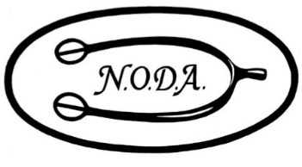
Northern Ohio Dressage Association
Expense Reimbursement Form
DATE
NAME
ADDRESS
CITY/STATE/ZIP
PHONE
EMAIL

EVENT | Choose an item.
EVENT DATE(S) | Click or tap to enter a date.

CATEGORY | DETAIL | AMOUNT
Choose an item.
Choose an item.
Choose an item.
Choose an item.
Choose an item.
Choose an item.
 | TOTAL

IMPORTANT INFORMATION
- Receipt copies for expenses claimed MUST be included with this Expense Reimbursement Form.
- Two ways to submit Expense Reimbursement(s) request and receipt copies:
  - US Mail to: Dee Liebenthal, NODA Treasurer, 783-3 Claridge Lane, Aurora, OH 44202
  - E-mail scanned reimbursement form and all receipts to: Treasurer@nodarider.org
- Expenses must be submitted no later than 30 days after the event for which it was incurred
to be eligible for reimbursement.
- Questions? Contact Dee at Treasurer@nodarider.org
Northern Ohio Dressage is a 501c3 Non-Profit Organization www.NodaRider.org Form 7/2018

